Technical Report

Giacomo Mastroddi  
16.06.2023

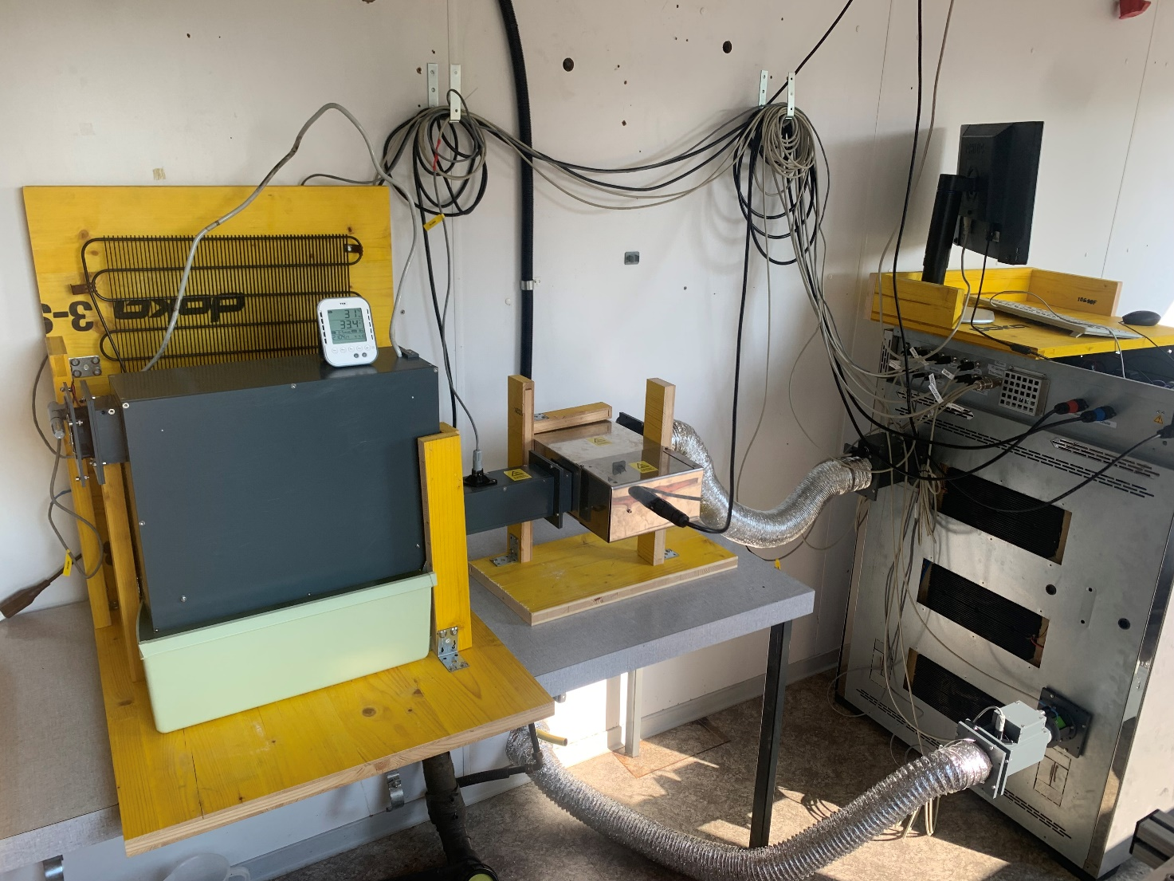

# Modeling

The modeling of the system is important to understand what can be controlled and how the system behaves to different inputs.

## Heating Process

The heating process can be modeled using an energy balance and assuming steady state conditions for the mass.

## Humidification Process

The humidification process can be modeled using the conservation of mass for the dry air and water.

## Cooling Process

The cooling process can be modeled using an energy balance and assuming steady state conditions for the mass at the contact with the cooling cycle (the fridge).

## Climate Chamber Losses

The losses of the climate chamber can be modeled using the analog resistance model.

In our case we have conduction between the inside and outside of the climate chamber and convection between the outside and the ambient.

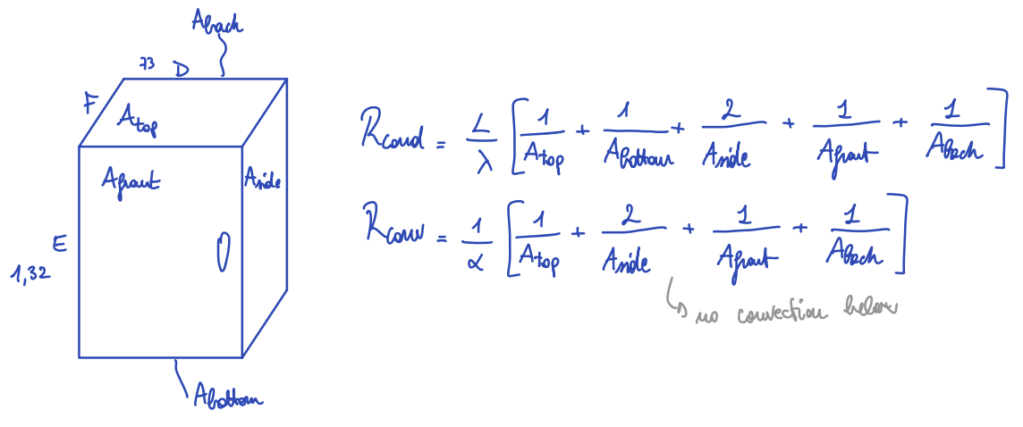

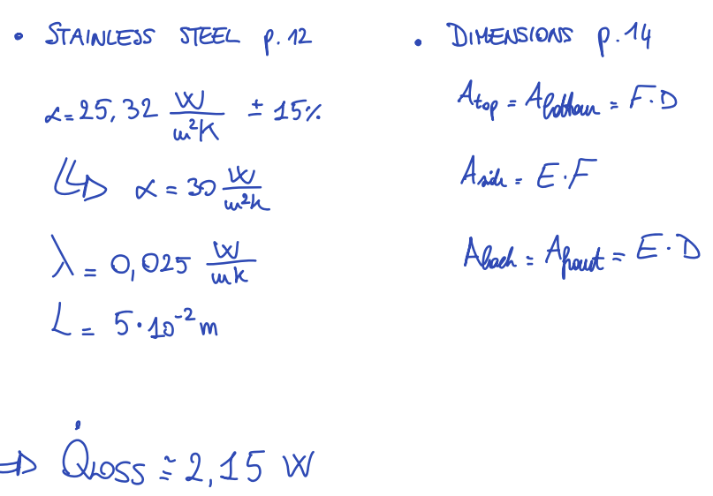Inserting the values from the datasheet of the Memmert chamber and values found online, we receive a total loss of 2.15 Watt.

A similar approach can be used to model the losses in the tubes.

# Process

To understand and control the system, a psychrometric chart has to be used. We assume that the pressure is atmospheric.

The relevant parameters are shown in red in the figure:

* T: Air temperature on the x axis.
* w: Humidity ratio on the y axis.
* rH: Relative humidity lines.
* A picture containing text, diagram, line

  Description automatically generatedh: Specific enthalpy.

Our sensors measure temperature and relative humidity. To obtain the other parameters we can use the PsychroLib on Python (<https://github.com/psychrometrics/psychrolib>):

* Documentation: <https://psychrometrics.github.io/psychrolib/api_docs.html>.
* Installation: <https://pypi.org/project/PsychroLib/>.

Example:

import psychrolib

psychrolib.SetUnitSystem(psychrolib.SI)

psychrolib.GetHumRatioFromRelHum(TDryBulb=27,RelHum=60/100,Pressure=101325.0)

## Separation in Scenarios

In our case, we have three possible process configurations to reach a point:

1. Cooling followed by heating.
2. Cooling followed by humidification.
3. Heating followed by humidification.

However, we decided to avoid using humidification device for simplicity.

## Process Overview

The temperature profile of the BSF facility could be separated into two phases: Chill phase in green and peak phase in orange.

The goals of the control system depend on these two phases:

* Chill phase: Minimal temperature of 27 °C.
* A picture containing text, font, screenshot, diagram

  Description automatically generatedPeak phase: Maximal temperature of 32 °C and maximal relative humidity of 60%.

The process itself is composed of a cooling element (an old fridge) and a heating element (an old heater), while no humidification element is chosen.

The real setting is the following.

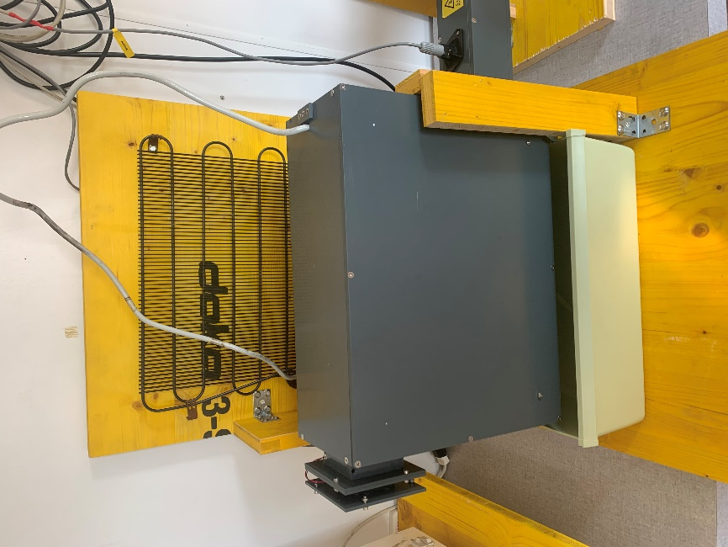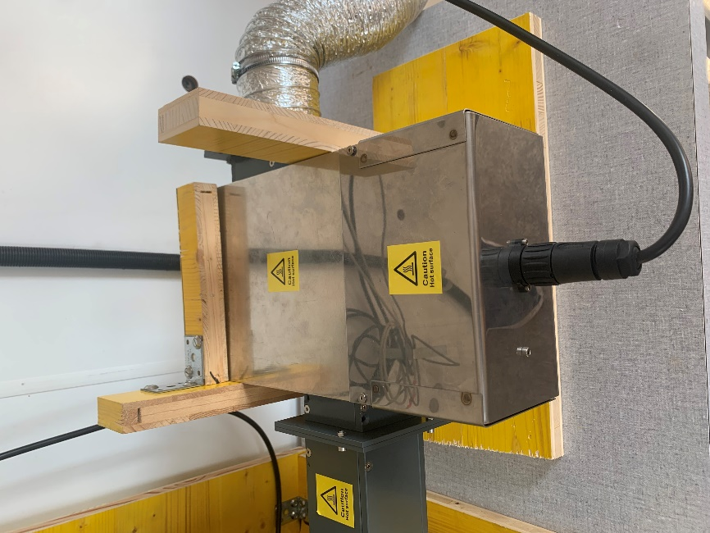

## Chill Phase

During the chill phase we follow the separation shown in this figure.

The conditions to decide the process configuration are shown in this figure.

For this phase, a simple PID controller is implemented, since there is a small delay between an actuator input and a sensor measurement (temperature at the inlet).

## Peak Phase

During the chill phase we follow the separation shown in this figure.

The conditions to decide the process configuration are shown in this figure.

For this phase, a simple PID controller could not be optimal, due to high time delay between an input from the actuators and a measurement from the sensors (the air must travel inside the chamber to be seen at the outlet). The delay time is approximately found knowing the volume of the tubes and chambers between the heater and the outlet sensor and the volumetric flow of the fans from the datasheet.

## Energy Recuperation

There are two possible ways to recuperate energy from this process using for both heat exchangers to preheat the air entering the heater:

1. Recuperate the extracted heat from the cooling.
2. Recuperate the heat produced by the larvae in the climate chamber.

# Code

The code is completely written in Python. The idea is to use an object-oriented approach to encapsulate all the specific differences between sensors and actuators.

In this figure are shown the dependencies between all the objects.

* An arrow indicates that an object sends information to the other object.
* A green box indicates an abstract object, or a parent class.
* A dashed box indicates a children object.

## State Machine

The state machine here is one part of the controller that decides in what state (or phase) is the process: Either chill phase or peak phase. The decision is performed with if statements, as shown in the figure. These statements reflect the separation explained before.

# Outlook

We are happy to have constructed such device. Some open tasks and points to be improved are list here:

* Use a controllable and more powerful cooler element (a modern fridge). This will ensure that a bigger portion of psychrometric chart is covered and the process better controlled.
* Label the end of the cables of the sensors to simplify the connection. However, the labeling machine was not to be found at the end of the service.
* Rearrange the cables to avoid any tension and malfunction.
* Use a humidifier to reach specific ambient conditions.
* Analyze the data with streamlit in an interactive way.
* Model the losses in the aluminum tubes.
* Build the energy recuperation possibilities and test the gained efficiency.
* Optimize the process by insulating the tubes.
* Buy other NH3 sensors or improve the calibration of the actual ones.
* Insert USB and HDMI connections directly on chamber wall to the electronic box.
* Solve the issues with RTC (Real Time Clock): The step-by-step instructions from the manufacturer caused the Raspberry Pi card to not functioning anymore  
  (<https://www.seeedstudio.com/blog/2020/07/07/raspberry-pi-rtc-tutorial-using-ds1307-and-ds3231-rtcs-with-raspberry-pi-m/>).
* Implement the controller for the peak phase.